LINUX COMMANDS

1.create a folder (or) directory:

# mkdir Mounika

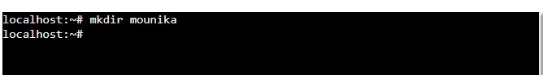

2.open a myfolder:

# cd Mounika



3.create a file:

# vi \abc.py

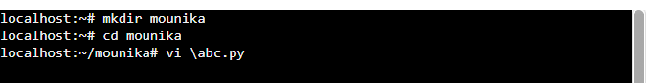

4.typing a python code in abc file :

# run the python file

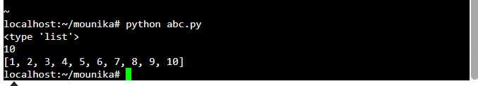

5.to see the list of data:

#we use ls

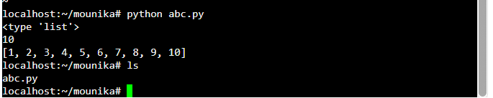

**6.pwd**

 #displays the current working directory.

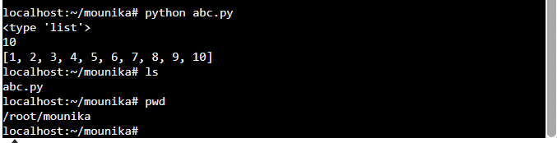

7. cd ..

# to came out from the directory or afolder

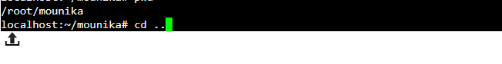

8.cd

# to enter into a folder

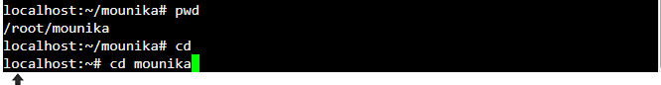

9.cp originalfile newfile:

# copying the originalfile data to new file data

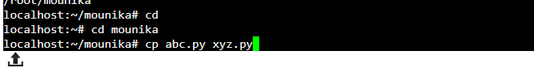

10.mv originalfile newfile

# move the old file data into a new file

# old file becames empty

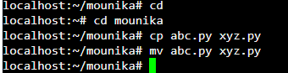

11.echo “type some text here”

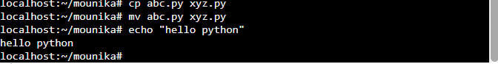

12.rmdir foldername(or)filename

#remove the folder

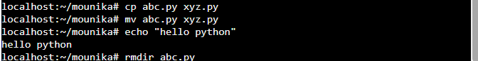

13.rm filename

#remove file

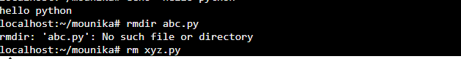

14.cat filename

# it is used to display the data

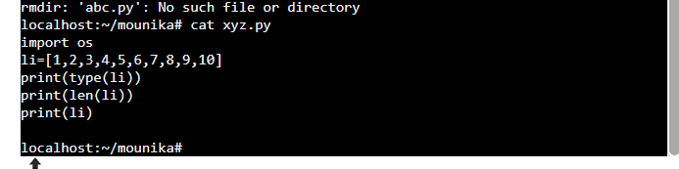

15.